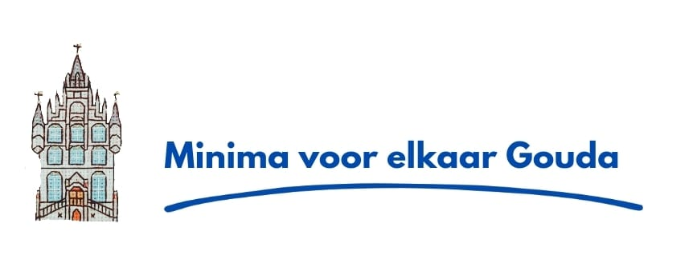Bicycles for people with a minimum income, free of charge !

In the Facebook group "minima for each other Gouda" free bicycles are offered for people who desperately need a bicycle but no money to buy one. There is some control, for example, you must either have a card from the food bank, or eg the Rotterdam pass (not the paid version), or have had the energy allowance of 1300 euros last year. Or you come up with a good story. Bicycles that are offered are fully checked and can be used immediately.
To get in touch with us, you can join our FB group.
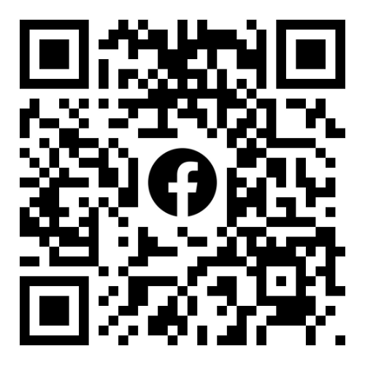minima voor elkaar Gouda

Groetjes Marcel van Waas

